COMPUTER ORGANIZATION AND ASSEMBLY LANGUAGE

TOPIC:
INPUTS AND OUTPUTS

NAME:
MUHAMMAD TALHA
ROLL NUMBER:
241890
SECTION:
4/A

INSTRUCTOR:
MS ROMANA MAROOF

EXAMPLE 2.1
Printing the character using assembly language:
Answer:
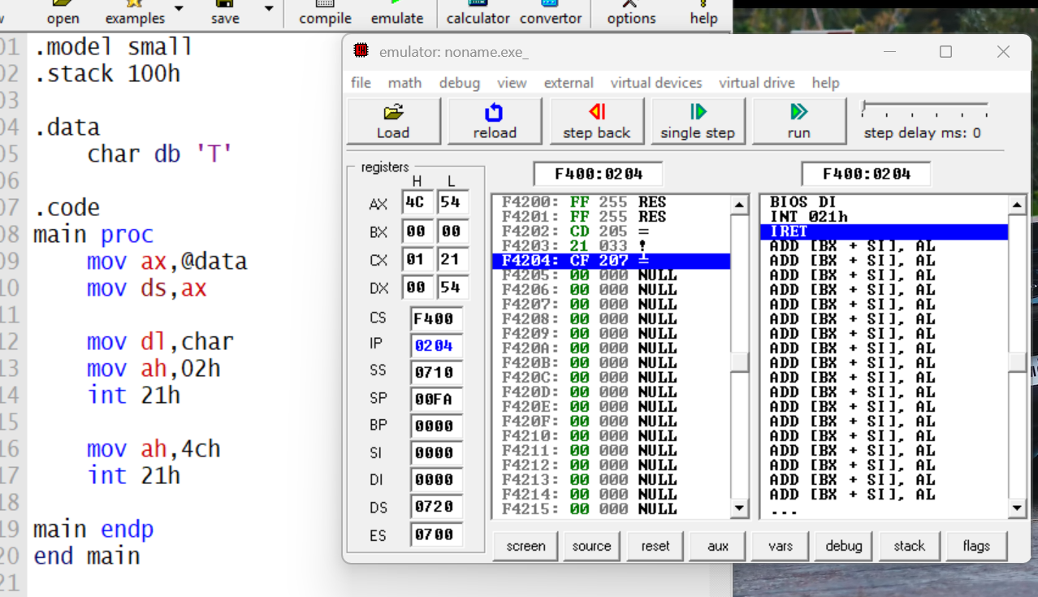
Steps:
- Adrees of data segment is loaded in AX regiter
- Address copied to DS
- Char value is loaded in DL register
- Function 02h is used to print the value
- Intrupt 21h is used to perform input/output (I/O) operations
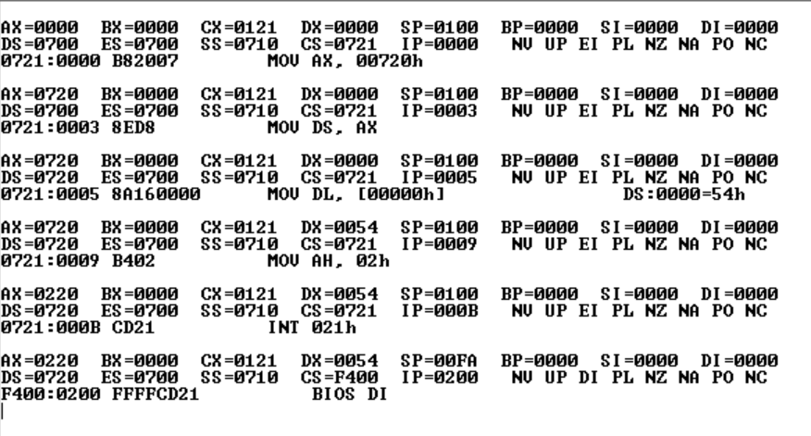
FINAL RESULTS:

EXAMPLE 2.2
Take char input and show it as out put
ANSWER:
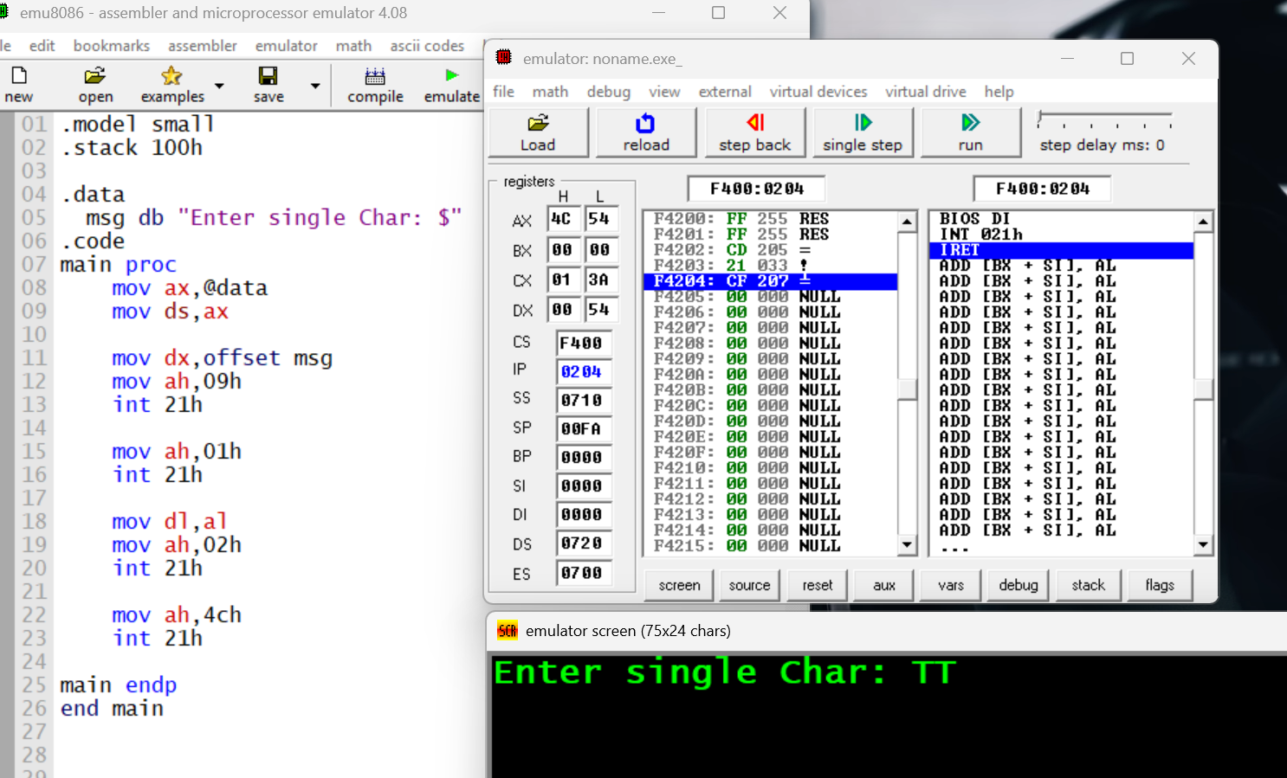
Steps:
- Load the address of the message into DX.
- DOS function 09h (print string).
- Call DOS to print the message.
- DOS function 01h (read single character).
- Call DOS to read a character into AL.
- Move the typed character from AL to DL (for printing).
- DOS functions 02h (print single character).

EXAMPLE 2.3
ANSWER:
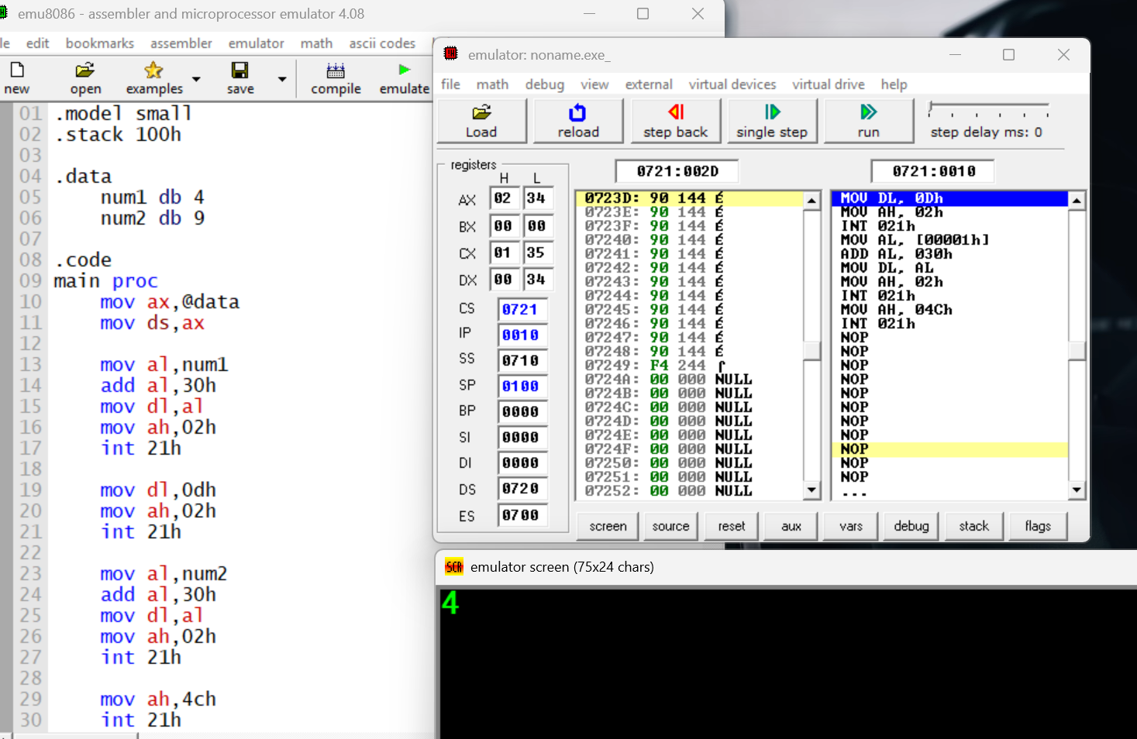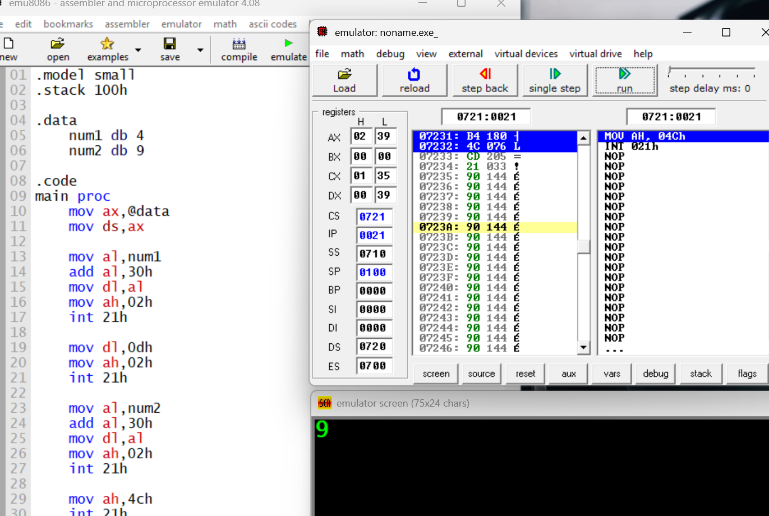
STEPS:
- Print the message "Enter single Char:".
- Read the first number from memory (num1).
- Convert the number to ASCII by adding 30h.
- Print the first number.
- Move the cursor to the next line.
- Read the second number from memory (num2).
- Convert the number to ASCII by adding 30h.
- Print the second number
EXAMPLE 2.5
ANSWER:
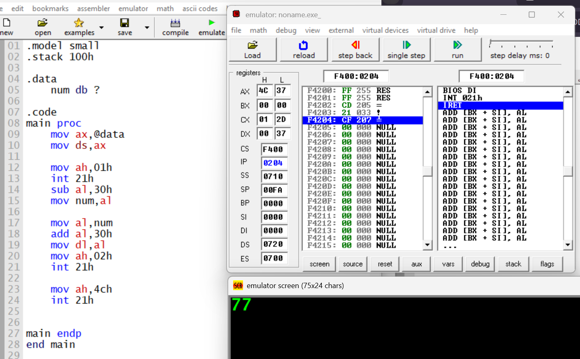
STEPS:
- Set up the data segment.
- Read a character from the keyboard.
- Convert the character from ASCII to number by subtracting 30h.
- Store the number in the variable num.
- Load the number from num.
- Convert the number back to ASCII by adding 30h.
- Move it to DL and print the number.
- Exit the program.
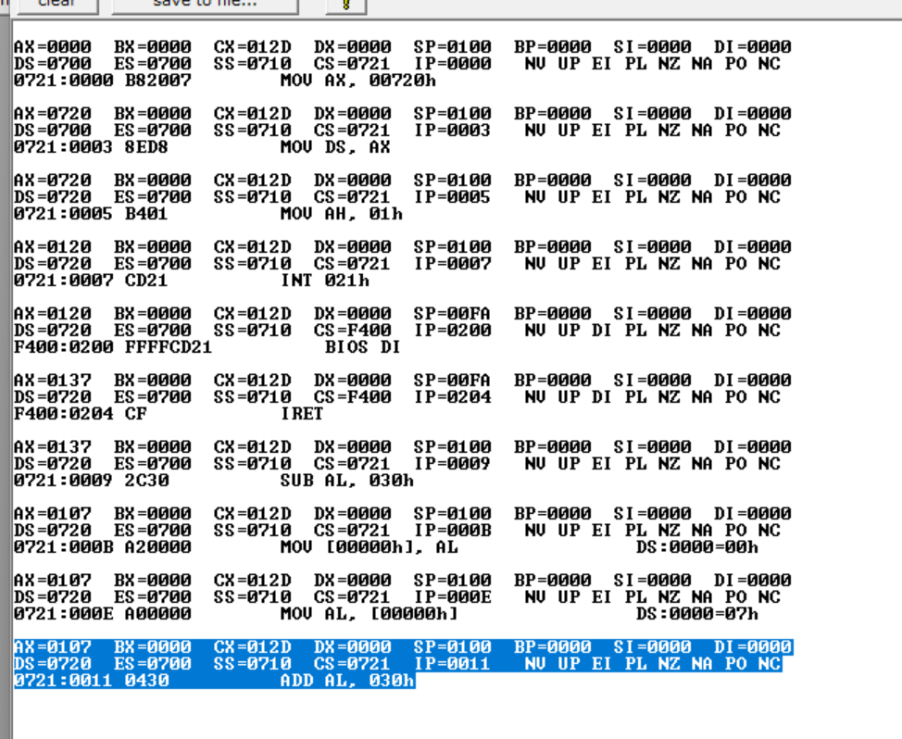
EXAMPLE 2.5
ANSWER:
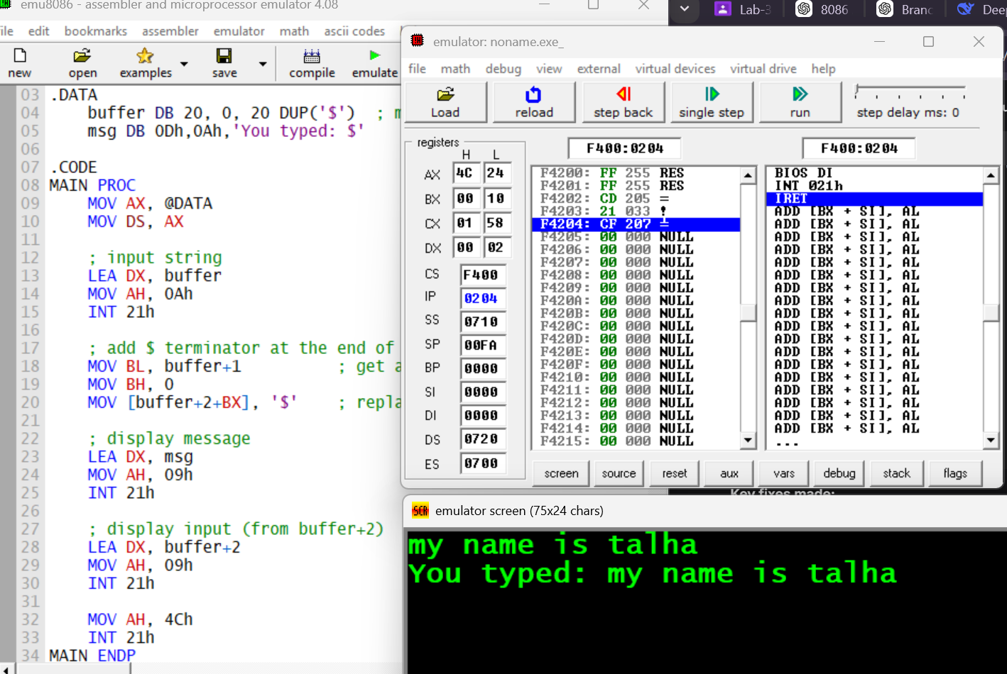
STEPS:
- Set up data segment with MOV AX,@DATA and MOV DS,AX.
- Read a string from the keyboard into buffer using DOS function 0Ah.
- Get the actual length of input from buffer+1.
- Replace the Enter (CR) with $ so the input can be printed correctly with function 09h.
- Print the message "You typed: " using function 09h.
- Print the user input from buffer+2 using function 09h.
- Exit the program using function 4Ch.

